**61. Use Dependencies Conditionally**

--- tree

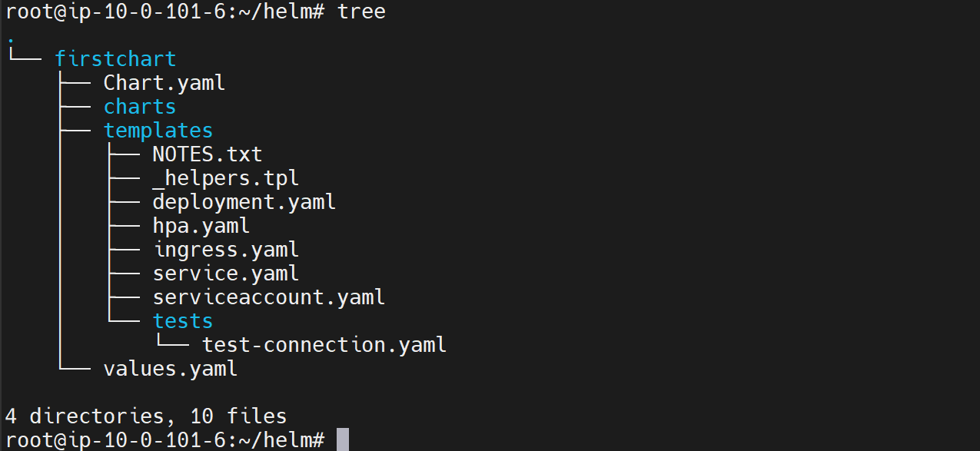

--- **note** - we define a chart dependency and we have the dependent chart under the charts folder, it will be used every time an installation or upgrade off our chart is done and that chart also will be installed on the Kubernetes cluster but if you want that to happen on a condition which you can pass from the values.yaml, it is super simple.

--- vi Chart.yaml

apiVersion: v2

name: firstchart

description: A Helm chart for Kubernetes

# A chart can be either an 'application' or a 'library' chart.

#

# Application charts are a collection of templates that can be packaged into versioned archives

# to be deployed.

#

# Library charts provide useful utilities or functions for the chart developer. They're included as

# a dependency of application charts to inject those utilities and functions into the rendering

# pipeline. Library charts do not define any templates and therefore cannot be deployed.

type: application

# This is the chart version. This version number should be incremented each time you make changes

# to the chart and its templates, including the app version.

# Versions are expected to follow Semantic Versioning (https://semver.org/)

version: 0.1.0

# This is the version number of the application being deployed. This version number should be

# incremented each time you make changes to the application. Versions are not expected to

# follow Semantic Versioning. They should reflect the version the application is using.

# It is recommended to use it with quotes.

appVersion: "1.16.0"

dependencies:

- name: mysql

  version: "~8.8.0-0"

  repository: "http://charts.bitnami.com/bitnami"

**condition: mysql.enabled**

--- **note** – add this condition to the mysql dependency in Chart.yml

--- values.yml

autoscaling:

  enabled: false

  minReplicas: 1

  maxReplicas: 100

  targetCPUUtilizationPercentage: 80

  # targetMemoryUtilizationPercentage: 80

nodeSelector: {}

tolerations: []

affinity: {}

**mysql:**

**enabled: false**

**# Install our firstapp using firstchart**

--- helm install firstapp firstchart

**# List the pods**

--- kubectl get pods

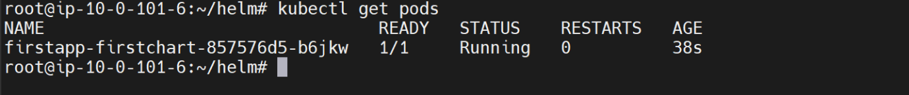

--- **note** – you can see that the mysql pod is not running because of the condition we mentioned in the values.yml.